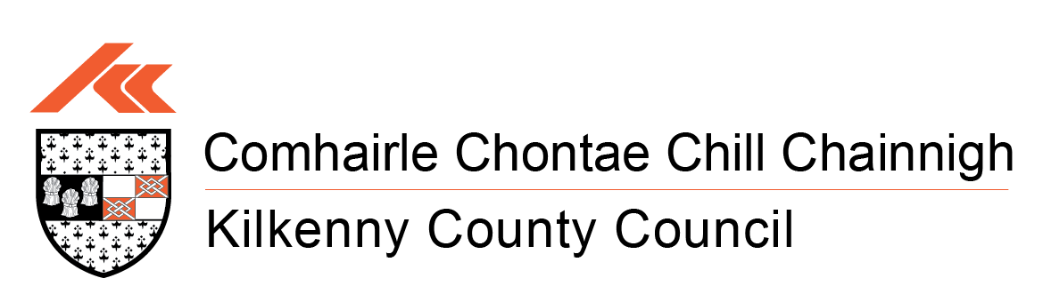

COMHAIRLE CHONTAE
CHILL CHAINNIGH

KILKENNY COUNTY COUNCIL

COMMUNICATIONS DEPARTMENT
External Social Media Policy

Table of Contents
Introduction …………………………………………… 3

Our Main Social Media Channels………………….. 3

Other Channels……………………………………….. 3

Like and Follow……………………………………….. 3

Block and Unfollow………………………………….. 4

Political Neutrality……………………………………. 4

Social Media Guidelines…………………………….. 4/5

Safeguarding allegations or disclosures………… 5

Data Protection……………………………………….. 5/6
Kilkenny County Council monitors its social media accounts between 9am and 5pm, Monday to Friday, except on public holidays.
Our Communications Team run the accounts. At times they need to pass your queries to other Council Services to get information for you. This can delay a reply to you, so please be patient. We will do our best to get back to you as quickly as we can.

Our main social media channels

Facebook https://www.facebook.com/KilkennyCoCo/

Instagram https://www.instagram.com/kilkennycoco/

YouTube https://www.youtube.com/user/kilkennycoco

LinkedIn https://ie.linkedin.com/company/kilkenny-county-council

Other channels
Some services have their own page. We also create pages for certain campaigns. Such as:
Kilkenny County Council, Community Development & Culture https://www.facebook.com/p/Kilkenny-County-CouncilCommunity-Development-Culture-100067863546111/
Kilkenny County Council Library Service https://www.facebook.com/kilkennylibrary/
Kilkenny Arts Festival https://www.facebook.com/kilkennyarts/

Like and follow
Please do not be offended if we do not 'like' or follow you on social media. It does not mean we do not like you or are not interested in what you have to say.
We often follow people who have information relevant to our work as a council. These include government agencies, local media and other public sector partners or those with information that may benefit you.
At times, we will try to lend our support to local and national campaigns. We may need to like or follow an account to be able to do this.
Please note: While we may like or follow a social media account, it does not mean we endorse them.

Block and unfollow
We try not to block accounts, but we may take this action for several reasons. These include, if a person repeatedly:
- breaks the rules of our social media platform.
- ignores our guidelines.

Political neutrality
The Council (not the elected members) must be neutral in how we communicate. Therefore, we ask you not to use our pages to promote party political messages or other content.
We will remove any comments we believe may compromise our obligation to be politically neutral.

3rd Party Comments
Comments posted by 3rd parties are the views of the 3rd parties and do not represent the view of Kilkenny County Council. Kilkenny County Council does not accept responsibility for any 3rd party comments appearing on its social media platforms.

Social media guidelines
We would love you to engage with us on these accounts. They are here to provide important information and advice to our citizens, businesses and visitors.
We do have some guidelines that we ask everyone to adhere to when they use our social media accounts.
We have a zero-tolerance policy against any form of cyber-bullying. It will not be tolerated on any of our channels.
We do monitor our social media, but if you notice any offensive comments at any time:
- send us a private message and let us know.
- or report it via the platform tools.
Please be aware: We will take action if, in our opinion, any content on our accounts:
- Is abusive or threatens. This includes swearing, adapted spellings with the same meaning and such.
- Is defamatory, slanderous, misleading or false.
- Intimidates our staff, elected members or other users.
- Is the same message posted multiple times, also known as 'spamming'.
- Is controversial, irrelevant and off topic, also known as 'trolling'.
- Incites hate crime or hate crime words.
- Is obscene, profane or sexually oriented.
- Discriminates in any way.
- Promotes illegal activity.
- Promotes individual products or services.
- Incites abusive and threatening behaviour away from social media.
- Is private or has details that identify a specific person. This is typically posted with malicious intent and known as 'doxing'.

What we will do if this happens
It depends on the content, but we may hide or delete it. We may also:
- screenshot posts and consider legal action or send them on to An Garda Síochána to investigate.
- and/or take immediate action to delete the post and block your account(s).
Note: from time to time we may turn the comments function off for some of our posts as they may be for information purposes only.

Safeguarding allegations or disclosures
Safeguarding is very important to us. If you raise concerns on our social media, we will pass them to the relevant organisations to be investigated.
Any posts about safeguarding issues will be removed while they are being investigated.

What we do with your data
We have a number of privacy notices to explain how our services use the information you give us. To view these, please see https://kilkennycoco.ie/eng/privacy/
Disclaimer
Kilkenny County Council accepts no responsibility or liability for any injury, loss, or damage incurred as a result of the use or reliance upon information or material contained on its social media platforms. It does not accept any liability for defamation because of anything which may be posted on its social media platforms by 3rd parties.

