**ISSUE NO 3**

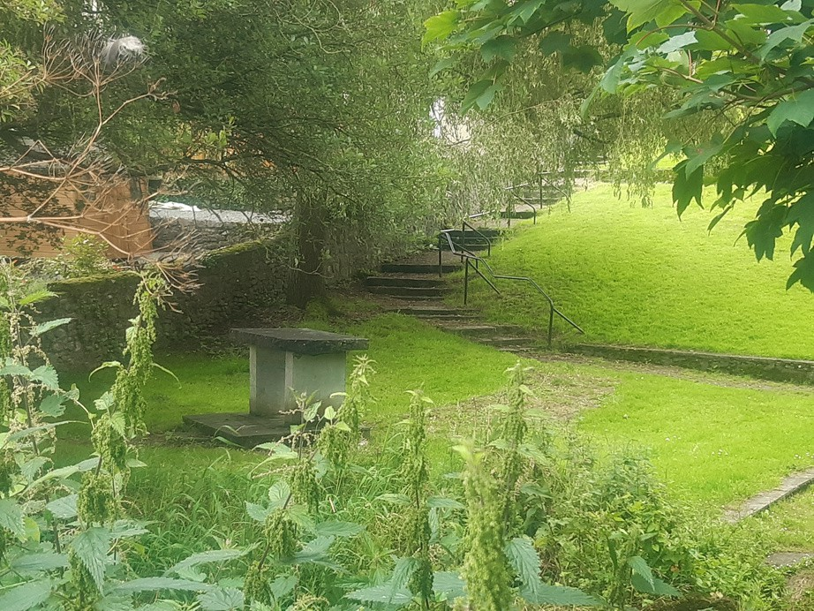**Newsletter October 2024 **

**BUTTS AREA REGENERATION**

Community Consultation Event

**Wednesday, November 6th, St Canice’s Neighbourhood Hall,**

**3.30-7.30pm**

**HAVE YOUR SAY!**

Have your say on the future of the Butts - drop in to the Neighbourhood Hall at any time between **3.30 and 7.30pm** on **Wednesday 6th of November.**

This event is being held to give everyone living in the Butts the opportunity to meet the consultants and give suggestions on future plans. The format is informal and people can give their suggestions in person or through a feedback form. This form can be returned on the day or submitted later, online or to the office at 19, Pearse St. It is vitally important that people call in on the evening to give their opinion!

**Household Surveys Community News**

Contractors have been appointed to carry out surveys of the house conditions in the Butts area, starting from mid- November. Many people who completed the Household Needs Survey answered that they would be happy to have such an inspection done on their houses. We will be in contact shortly to arrange the details of these surveys.

The reports and information from this process will give greater details of issues arising in houses in the area. This will form part of the future planning process for the Butts Area Regeneration Project.

**Logo**

The Tidy Estate clean up event was held on Saturday 12th of October. it was a great success, with plenty of volunteers and lots of tasty treats after! Thanks to the Kwik Mart on Lord Edward St for donating water and other supplies for the refreshments. We hope to make this a regular event in the community.

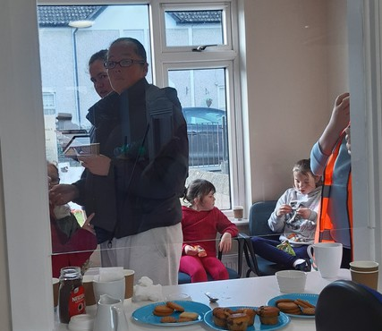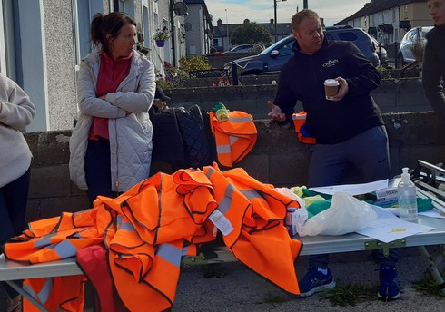

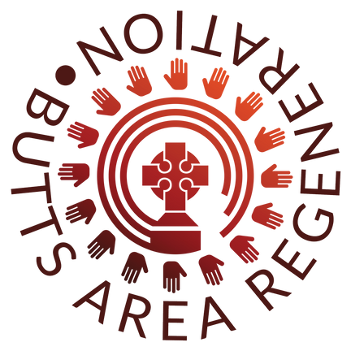A new logo has been designed in conjunction with the Town Team and the Heritage sub-group for the Butts Regeneration Project. This will be used on the site office and all

project related materials