**ISSUE NO 1**

Newsletter



**September 2024**

# THE BUTTS REGENERATION PROGRAMME

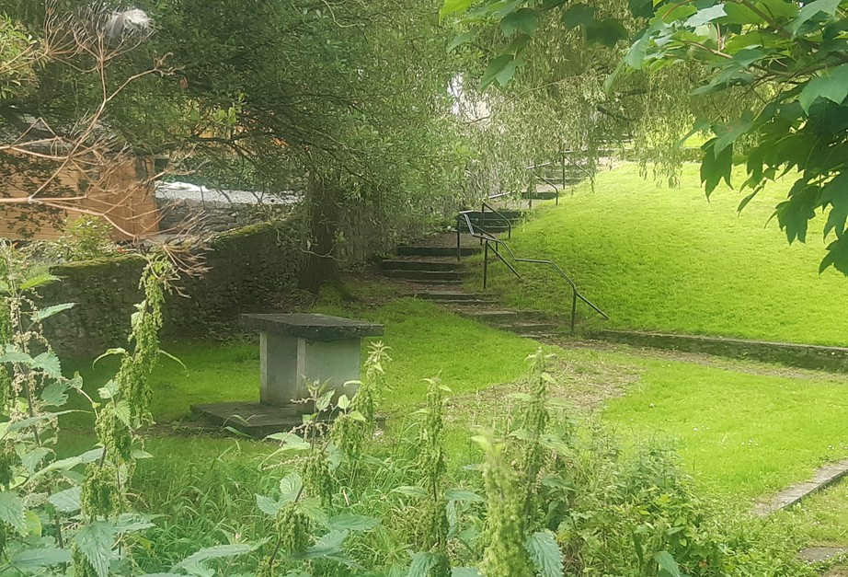

**The Butts Regeneration Project**

Welcome to the first of our forthnightly newsletters with information and updates!

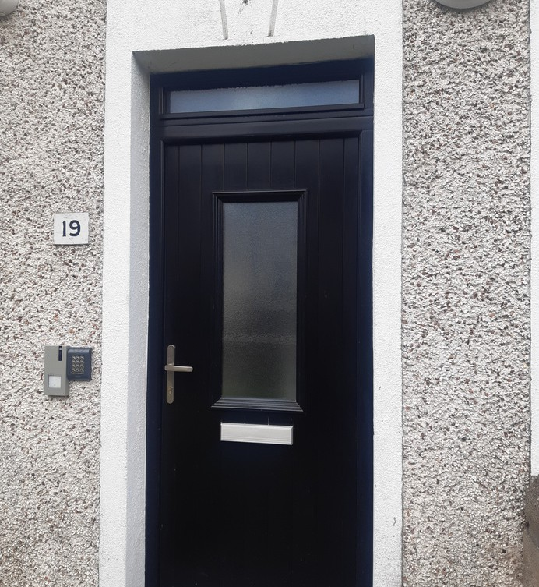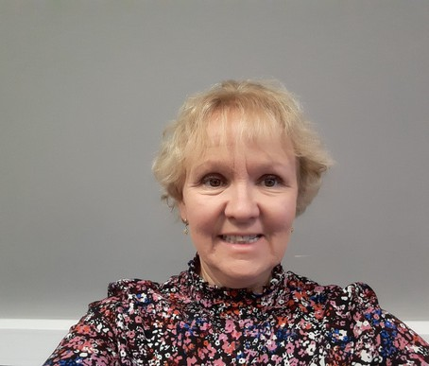

# Introduction

My name is Marie Smith and I have been appointed as the Community Liaison Officer for this project. As Community Liaison Officer, I am interested in getting your feedback.

I will be available in the office during opening hours should you have any query or issue relating to the Butts Regeneration Project or can be contacted also by email (marie.smith@,kilkennyco co.ie)

The site office in the Butts will be opening soon and will be accessible to the public on a regular basis. The opening times initially will be **Tuesday, Wednesday and Friday, from 10.30 to 2.30.** The address of the office is **19, Pearse St.**

The consultants for the process have also been appointed and are working hard, having visited the area and met with Town Team representatives. They are Vincent Hannon Architects (VHA) and Aisling Leahy and Annie Mitchell both came to Kilkenny in mid- July to familiarise themselves with the issues and the area.

**Community News Event News**

# Estate Management

A grant has been secured to carry out work around the area such as litter picking and some materials will be bought to help with this ongoing maintenance, such as sweeping brushes, bags, gloves, etc. The work will be ongoing over the next few months.



# Survey of Housing Needs

We have been working on carrying out household surveys with all residents of the Butts area over the last couple of months and the process is now nearly completed. Thank you to all who have participated so far. If you have not filled out a survey, please contact us and we will arrange to get one completed with you as soon as possible.

# Events

**Copper Wire Workshop**

A copper-wire workshop will be hosted by Emma Jane Champley in the Neighbourhood Hall in the Butts on Friday 4th of October, from 10 to 5pm.

This will be a day long workshop and is mainly aimed at adults. With participants either working together in pairs or individually over the course of the day, you will come away with a finished copper creation. The facilitator will be Emma Jane Champley and the workshop is funded by Creative Ireland. Please contact me at [**marie.smith@kilkennycoco.ie**](mailto:marie.smith@kilkennycoco.ie)for more information and to book in to this workshop.

# Age Friendly Programme - Mayfair Library, Parliament St, R95 N23R

The Mayfair Library will host a programme of events for older people, between 6th of September and 1st of November. The next event ***Kilkenny Age Friendly Strategy*** will be hosted by Nollaig McGuinness, Consultant for the next Kilkenny Age Friendly Strategy. This will take place on Friday 27th of September from 11 to 1pm.

Contact 056 7794174 for more information.

