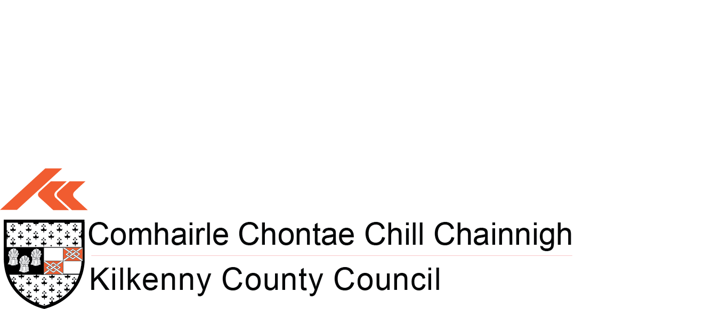

**NOTICE OF THE PASSING OF RESOLUTION UNDER SECTION 20(2) OF THE FINANCE (LOCAL PROPERTY TAX) ACT 2012 (as amended)**

Kilkenny County Council

In pursuance of the provisions of section 20 of the FINANCE (LOCAL PROPERTY TAX) ACT 2012 (as amended), I the undersigned, hereby notify the Minister for Housing, Local Government and Heritage of the passing, of a resolution at a meeting of the above mentioned local authority on 16th September 2024 to the effect that the basic rate of local property tax should stand varied upwards by 15 per cent for the years 2025-2029 in respect of relevant residential properties situated in the local authority’s administrative area.

Signed: 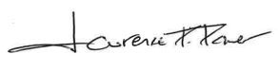

Chief Executive

Dated: 23rd September, 2024