Radon Information Sheet

What is radon?
Radon is a radioactive gas which is naturally produced in the ground from the uranium present in small quantities in all rocks and soils. You cannot smell, see or taste radon and it can only be measured with special detectors.
Why is radon a problem?
Radon is a radioactive gas which produces tiny radioactive particles. When inhaled, these particles are deposited in the airways and on lung tissue, giving a radiation dose that can cause lung cancer. Radon is in the same group of carcinogens as asbestos and tobacco smoke
Your risk of contracting lung cancer from exposure to radon depends on the level of radon you have been exposed to and duration of exposure.
Two groups of people are more at risk and should take action to reduce their exposure:
- Those living in a home with high radon levels.
- Those who smoke or who used to smoke.
Smokers run a much higher risk of developing radon-related lung cancer than those who never smoked because when the two carcinogens radon and tobacco smoke are combined, the risk is magnified.
There is no scientific evidence linking radon with any other types of respiratory illnesses or other cancers.
The Government has set a level of 200 becquerels per cubic metre (Bq/m³) as the national Reference Level or 'acceptable level' for radon in homes above which the risk is unacceptable.
The becquerel is the unit in which radioactivity is measured.

What is the extent of the radon problem in county Kilkenny?
In the map of Kilkenny below, High Radon Areas are depicted as the brown and dark brown coloured grid squares.
A 'High Radon Area' is one in which more than 10% of homes are predicted to have radon levels in excess of the Reference Level (or acceptable level) of 200 Bq/m³.
Many parts of Kilkenny are designated by the Radiological Protection Institute of Ireland (RPII) as High Radon Areas.
The RPII (www.rpii.ie) have an interactive radon map which you can search for your home address or nearest town to see if you are in a High Radon Area.
Even if you do not live in a High Radon Area, you still may have high levels in your home. The only way to know is to have your home tested.
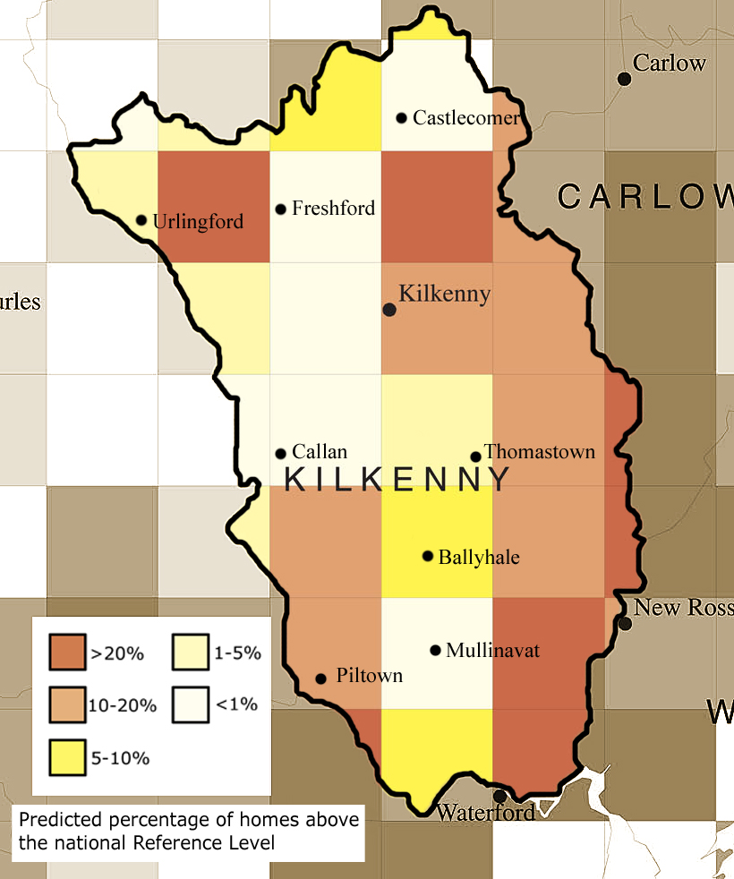

How does radon get into my home?
Radon can enter a building from the ground through small cracks in floors and through gaps around pipes or cables
It is generally warmer inside your house than it is outside. This temperature difference results in a lower indoor air pressure relative to the outside which causes radon to be sucked from the ground into a building.

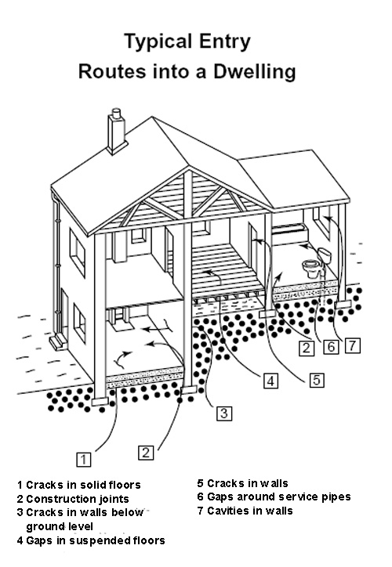

Building regulations - provisions required for radon gas
Since 1998, Irish Building Regulations have required that reasonable measures be taken during the construction of new buildings to avoid danger to health due to radon. Specific technical guidance published by the Department of the Environment, Community & Local Government (DECLG) requires that all homes built since July 1st 1998 must be fitted with a standby radon sump which can be activated at a later stage, to reduce any high radon concentrations subsequently found. For homes built in High Radon Areas, the installation of be fitted with a radon barrier as well as a standby radon sump is required. The guidance also outlines the requirements for radon barriers.

What can I do to protect myself?
Get the levels of radon in your home measured.
Most homes tested will be found to be safe, giving homeowners’ peace of mind. Where unacceptable radon levels are found, the majority will have moderately high levels which can be fixed by improving the ventilation in a house. This work can be done at a low cost or indeed by a DIY enthusiast.
A popular method to reduce any level of radon gas requires the creation of a sump – a small void under the house which is then piped to the outside. The work can be done within a day and from outside the house so there should be no internal disruption. Surveys carried out by the RPII report the typical costs for this work are about €850 (€450 - €1150). The on-going running costs were found to vary from about €50 to about €110 per year, depending on the strength of fan used (between 30 and 70 watts).
There are a number of companies in Ireland who can do this work and further details can be found on www.rpii.ie. The costs should be lower for houses built since July 1st 1998 as they should already have a standby sump in place.
A booklet entitled Understanding radon remediation - A householder's guide will help you learn more about the solutions available and how to deal with the problem. Technical guidance on radon remediation techniques is also published by the DECLG.

How does a radon measurement work?
A radon measurement is usually carried out by placing two small detectors, about the size of a digestive biscuit, in your home for three months.
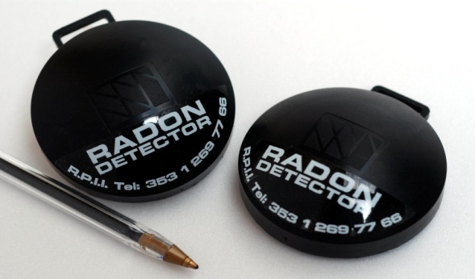
One detector is placed in a bedroom the other in a living room - the places most occupied by the homeowner and family.
After three months, when the detectors are returned to the laboratory, they are analysed to see how much radon they have been exposed to.
Once the results are known, a report is issued to the person who requested the measurement indicating the average level of radon in their home and advice on what to do next if it is a high result.

Where can I get a radon measurement?
A number of service providers provide a simple and inexpensive radon measurement service for your home and for the workplace. Further information can be found on www.rpii.ie

