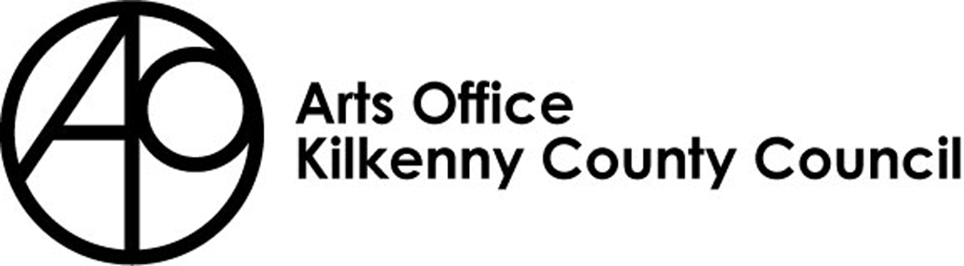
Literature Mentoring
Application Form 2021
Closing Date: Wednesday 21st April 4pm

Note:
- Please ensure that you read the form fully and complete all sections
- Incomplete applications will not be processed
- Remember to allow sufficient time for completion and delivery of application before the closing date.

Personal Details
Name:
Current Residential Address:
Telephone:
Mobile:
Email:
Are you registered with ArtLinks?
Are you on the Kilkenny Arts Office database?  How long have you been resident in Kilkenny? | ______________________________________________________________________

Applicants must be currently living in the Local Authority administrative areas of Kilkenny for a minimum period of 2 year

Previous Awards Received:
Have you received Arts Office Mentoring support in the past?
Yes No

If ‘YES’ what year did you receive the mentoring support ?
______________________________________________________________________________
What type of mentoring support did you receive?
______________________________________________________________________________________________________________

GIVE DETAILS OF ANY PREVIOUSLY PUBLISHED WORK (if applicable)
Title of publication | Year published

Previous AWARDS:
Give details of any other previous awards received, including those from national and local organisations, e.g. Arts Council, ArtLinks, Local Authority, other professional organisations.
Title of Award | Year Received | Amount Received

Previous Development Courses:
Please list details of any professional development courses and / or education you have for your writing
Title of Course | Organised By | Year Attended

For what purpose do you wish to avail of mentoring support?
Give a brief description of the purpose for which you are applying for this mentoring support and how you believe this support will develop your practice (Max 300 words)

If successful, the mentee must:

- Meet with their mentor on the date and at the time agreed
- Be willing to invest personal time in preparation for the mentoring session
- Agree to complete a post-mentoring Evaluation Form and return it to deirdre.southey@kilkennycoco.ie by the agreed date in their letter of offer

I have read the conditions applying to the kilkenny arts office Literature Mentoring 2021. The information I have supplied is correct to the best to my knowledge. I agree to be bound by the terms and conditions of this scheme.

Signature:
Print name:
Date:

Completed application forms must be received
no later than:

4 pm, Wednesday 21st April, 2020

Please note that late applications will not be accepted.

